
Letter from Chair

Nights are drawing in again so please make sure you are safe and can be seen, reflective items can be purchased from many outlets e.g. Simply Running, Tesco, and Argos to name a few!! Its a busy month for many with the Fair and Halloween and half term but try and keep your running up with the club even when it looks miserable as you will benefit both mentally and physically from it. Great turn out at Howden 10k and looking forward to Haltemprice 10k later in the month. Lovely to see so many ladies out and about running together, its what the club is all about.

Antonia

West Hull Ladies R.R.C Committee Meeting
Monday 5th October 2009

Attendance: Debbie Watson, Victoria Voase, Jo Townsend, Laura Caley, Julia Lovel, Ruth Upfold, Sharon Hartley, Yendis Westerman, Suzanne Clarkson, Antonia Goodison, Amanda Dean, Rebecca King
Apologies: Lynda Hields, Gill Jackson

Headlands 10k
After a discussion about the race going forward it was agreed Antonia would put together a detailed project plan of required actions and deadlines to share with the club. This would provide information required to make a decision on whether the race would go ahead in April 2010. The project plan would be circulated by 16th October, any comments or amendments from the club are to be submitted by 23rd October and a vote as to whether to go ahead is to take place on 2nd November.
Safety Talk
The safety talk was discussed and it was agreed to postpone in light of the sport psychology talk.
Sports Psychology Talk
It was agreed that friends and family could also attend.
Christmas Run
The date of the Christmas run was agreed as 21st December. Mince pies and mulled wine to be arrange for afterwards.
Hill Training
The location of hill training was discussed. Various locations were suggested. It was agreed to postpone hill training for October in light of the safety issues until a suitable location had been agreed on.
Liaison Officer
A vote was held to appoint the new Liaison Officer. Annette Pearson was voted in as the new officer effective immediately. It was also discussed that Gill Jackson wished to resign from the post of Racing Officer. It was agreed to ask Gill to provide some information on the duties of the racing officer to circulate to the ladies. The ladies would then have an opportunity to put themselves forward for the role.

Sunday Runs
It was agreed that a Sunday run would be started for any ladies who wished to join in. The run would be off-road around Beverley Westwood. The run would set off at 9am from the burger and ice cream vans. Various distances would be available and all ladies would be taken care of. The runs are to commence in November and anyone interested to inform Antonia.
Hotmail Account
The contact list of the email account was discussed. It was agreed that the contact list would be split into two lists – West Hull Ladies 1 and 2 – so that the emails could be accommodated as the club continued to grow.
London Marathon
The draw for the club places was discussed and the criteria to allocation of places reaffirmed. This would ensure members who ran regularly with the club had first refusal. Only those who had applied for a place through the ballot and not been successful would be eligible to go in for the club places. Proof was required. The club needs to apply for the place shortly.
Late Payments by New Ladies
It was noted that some ladies were running with the club regular and not joining. Yendis tracks who has run for more than 3 times and not joined. It was noted that one lady had taken a vest and had not paid for it or paid membership. It was agreed a letter would be drafted.
Fundraising
Volunteers are still being sought to take on fundraising for the club such as Webb Ivory Catalogue or the Bonus Ball.
Press Officer
Julia is eager for the club to have a say in the redevelopment consultations re West park to ensure the facilities are still available for the club runs.
Treasurer
Victoria asked for clarification around making purchases with club funds and how this is authorised. It was agreed that three committee members agreement would be required. This would normally be Treasurer, Secretary and Chair (however this would need to be flexible to other committee members in the event of holidays etc). Amanda showed the committee the stopwatches which had been purchased for speed-training. UK Athletics was discussed. It was agreed that the remittance contact email be changed. Victoria said the accounts were up to date with the exception of receipts for £90 of payments which she was awaiting. A cheque had been issued to Olivia Bussey to refund £3 overpayment of fees. Victoria requested that ladies wrote their names on the back of the cheque when they sent it in. It was agreed the form would be updated to request this.
AOB
It was discussed that some ladies had asked about the format for Wednesdays run as some ladies had been left alone. It was confirmed that no lady is to be left to run alone and groups must stay together. This is one of the most important rules of the club. If this means faster ladies have to run back to pick up slower ladies than that is to be done. This means faster ladies cover more distance. Ideally groups should be no smaller than 3’s. This is for safety reasons also.
Next meeting 2nd November 2009 – after Sport Psychology Talk

Training Officer Report

A big welcome to our new ladies. Hope you are enjoying running with us and hope you’ve found that everyone in the club is friendly and approachable.

It’s been an excellent month for training and we see ladies improving week by week and I suspect they are surpassing any expectations that they had when they joined the club. I am really looking forward to seeing how everyone performs in the Howden 10K, wishing I could be with you.

Setting a goal for yourself is the easiest way of ensuring you stick to your training and improve. A race is definitely worth working for. But, if you are happy with what you are doing, it is OK to just stick at that level and enjoy it. However, experience shows that most people get a great sense of achievement from going that bit further or that bit quicker and this rubs off into the whole of their lives. Work problems are much more manageable when you sliced 10 seconds off your fast mile pace the night before J

You will see that the club has arranged a talk from 2 experts in the fields of Sports Psychology and Sports Science on Monday 2nd November. This will be really worth going to and hopefully will inspire you to have faith that your body is capable of amazing things – probably much more than your head will ever allow it to do.

If you have any suggestions to improve running at the club, don’t hesitate to send an email or bring it to the club meeting. Suggestions for our monthly “away night” runs are always welcome. These have to be no more that 20 minutes drive from the club, must be in lit areas and with a route that can offer at least a mid (5-6M) and longer (7-10M) running route.

Enjoy your running,
Amanda

Some of us were aware that Becky Dockerill was going into hospital for an operation on her foot. Here she shares the details with us – with pictures!!

Becky: I had a bunion for as long as I could remember. I was always in discomfort and often in pain but because I couldn’t remember a time that I didn’t have the bunion, I just put up with it. Most people associate bunions with wearing poor fitting shoes or high heels – but in my case, it was hereditary as my mum has bunions so although I wasn’t born with a bunion, I was more pre-disposed to develop one.

It wasn’t until I went to see Kirstie Skelton that she explained how the bunion was affecting me – for example, the bunion was on my left foot and the muscles in my right leg were more developed than those in my left leg and I was having problems with my right knee – because my right leg was over-compensating for my left. Kirstie encouraged me to get my foot checked out so I initially went to my GP and was referred to a podiatrist, however he wasn’t much help - in fact telling me that it wasn’t actually a proper bunion! The podiatrist did however explain that I should ask for a referral to an orthopaedic surgeon – so I went back to my GP and had an appointment within 3 weeks to see an orthopaedic surgeon. He was very helpful and spent time explaining to me about the mechanics of the foot – although we have 5 toes, the big toe contributes 40% to the movement of the foot and my bunion was making my big toe redundant so I was using only the ball of my foot and the heel, causing me all sorts of complications with walking and running. He also explained that the bunion would only ever get bigger and recommended surgery
. 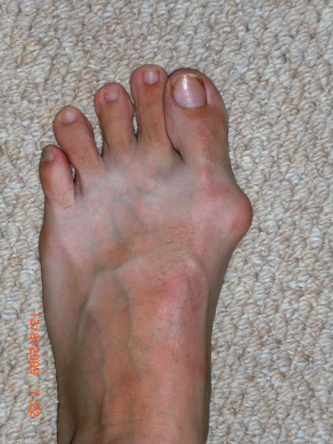
before the op

Only 6 weeks after this consultation, I had the operation on the 17th August, under a general anaesthetic. The surgeon removed the bone from the side of my foot and straightened all the soft tissue inside my foot. After a week the bandages came off and I am now wearing a splint for 7 weeks to ensure that the soft tissue and my toe heal straight. I can’t put full weight on my foot but have to hobble along on my heel and I can’t drive yet. The splint should come off in the middle of October when I can start to wear a shoe on my left foot again! The surgeon has advised that I shouldn’t run for about 6 months. I also have 9 weeks off work and despite my best intentions, am watching lots of daytime tv! The first few weeks passed in a blur of pain and painkillers and I barely moved from the sofa but now I am able hobble about quite well and have even started venturing outside, although for longer trips I have a wheelchair that I hired. I still have to rest my foot, keep it elevated as much as possible and do my physio exercises. I hope in the long term that this operation will be successful and my running will benefit with faster times and I may even consider a marathon!

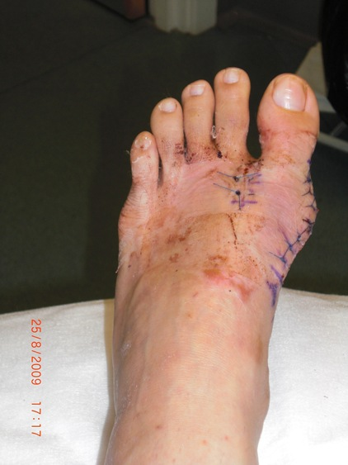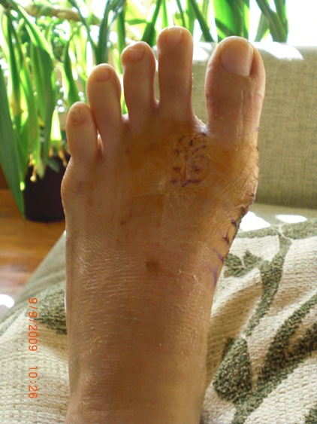
post op - one week and three weeks

Race Write-Ups or Write-Offs

Beverley Triathlon 23 August 2009

Antonia: I decided sometime ago that I quite fancied trying a Triathlon when I returned to running post baby James. I signed up for the Beverley Triathlon as soon as it opened as it was my old stomping ground and it was a new event . I spent the early part of the summer catching up with my swimming technique and running, though must admit neglected the biking part and only managed 1 10 mile bike ride on the fantastic bike Becca loaned me. Race day arrived and I got up very early for the race start, that in itself was a challenge!!
Arriving at the race HQ i was fully expecting ,as a complete novice, the promised video briefing so I had at least a little bit of a clue what to do. Unfortunately there was no video briefing and calmness soon went to panic!! Luckily Becca had done one before and explained the process very well and calmed my nerves.
Swim first and that was ok, went a bit quicker than expected so that was good, then transition seemed to go ok too then onto the bike! I loved the route of the cycle part as it went past my old house and all the places I used to get up to mischief as a teenager, I probably took far too long reminiscing as I seemed to get slower and slower!! Transition 2 was a bit easier and despite warnings of wobbly legs post cycle I really got into the run. I didn't know the run route at all and the end seemd to come a bit quicker than expected. All in all I really enjoyed it , not sure you are supposed too, and have already done my 2nd Triathlon and looking forward to my 3rd!! If you fancy a change why not try a TRI!!

Major Stone Half Marathon 6 September 2009

Debbie: Major Stone was my third half marathon this year and I felt quite confident, having managed a 15 mile run during my training and being injury free. The weather was cool, ideal conditions for a long run. I felt very comfortable for the first 5 miles, in fact Emily asked me if I knew how fast I was going, she soon settled into her stride at 5.5 miles and became a speck in the distance. At the loop around at the half way point I was convinced I had an up hill to do, however once I ran around the cone I realised that it was relatively flat, the hill was an optical illusion! Things got a bit tougher after 8 miles and I had to dig deep and give myself encouragement after each mile, I had passed caring at mile 11, 12 and 13 and didn't dare look at my watch because I was not sure how I would feel if it was a good or bad time so I chugged on to the end and was delighted with a pb of 1hr 52.

Amanda: I rather like this half marathon. It runs through undulating country lanes with relaxing views. It starts and finishes in the pretty village of Lockington and has a village hall with tea, cake and sandwiches for after the race - though the spectators had scoffed a lot of it before us hard working runners made it!

I have a plan to get under 90 minutes though whether that will ever become a reality has to be seen. It is a big ask of myself (6mins 45secs per mile) …. and I’m not getting any younger! However, although I didn’t make it today, I finished pretty close to my 93mins PB which means I am not getting slower either.

The weather conditions were very good, it was a little windy but cool and dry. For the first 5-6 miles I really enjoyed the race however, at 7 miles I started to lose my pace, legs a bit dead and I couldn’t will any speed – but it was quite bearable up until 10 miles. After that, just the usual – it hurts and it’s hard to keep pushing on because you really want to give up and be comfortable again. I am now called an experienced runner. This I know means that I have been there, hurt a lot and come out OK at the end. So with my experience I went there, hurt a lot and finally finished. I was a little disappointed, but not for long when I put it in perspective …. I was 2nd lady so I am proud of myself.

I grabbed my camera and went to chat to other runners and wait for our ladies to come in. I was amazed to see Emily racing in well under the 1hr 50mins I expected of her (1hr 48mins) and Debbie just a few minutes later in 1hr 52mins. Laura and RebeccaD came in 2hrs 9mins which was a great run for both of them.
We nearly took the team prize – Beverley Girls got 9th, 10th, 11th lady club runner positions which adds up to 27. Me, Emily and Debbe got 2^{nd,} 12th and 15th which adds up to 29 … so very close.

Rebecca: I turned up at this race more ill-trained and unprepared than in any other race I’ve done and I don’t plan on doing it again. My training involved a maximum of two runs a week, missing all of the weekly total targets and getting up to 9 miles at the most. I was unprepared because I spent the previous night in a bivvy bag having spent quite a lot of time barn dancing (Guide camp) – this proved to be the worst thing as it meant I started on a calf so tight I limped to the start line, optimistic though and thinking “It’s going to hurt but I’ll live”.
As I set off, happy that I wasn’t limping once I’d started running, my goal was to keep Laura in my sights. This was quickly set aside and replaced by an aim of getting past the fat man with shorts half-way down his bum, something I did not want in front of me for 13 miles. Passed him after 2 miles and returned to my original goal. I would like to attribute the next 11 miles entirely to mindless optimism. At 3 miles “If this is how bad I feel after 3 miles how bad will it be after 10” was replaced by “that’s 3 miles I’ll never have to do again”, “It could be worse” repeated often throughout the race and at some points almost as a mantra along with other equally cheerful variations on that theme.
Caught up with Laura at about 6 miles before having to stop to stretch, it then took me 5 miles to catch up with her again, I struggled to keep up with her for the last 2 miles but we finished together with a time of 2:08, a PB for me and very good first run for Laura.
After I swore I wouldn’t run another one of those for a while but now I’m left wondering; how well could I have done both trained and prepared…

Burton Pidsea 3 Run Challenge 13 September 2009

Yendis: I'm not really sure why I decided to take part in this challenge, it was one of those things that seems like a good idea at the time. I knew that 60% of the course was off road, so I had no thoughts of doing a good time, it was really just to be able to say I had done it. Even Kelvin was suprised when I said I going to attempt all 3 races. I was really surprised at how few competitors there were. The 2k started at 10am and was all off road, an out and back route, with a few children and probably no more than 30 runners in all. Just under 11 minutes, all going well at this point. The 6k did not start until 11am so there was time to get topped up with energy drink before going back to the start. Luckily it was not as warm as the day before, but it was very windy, as I found out in the next race. There were even less runners in this one and again, most of it was off road. I did not think there could be so many uphill sections in such a short distance and most of the way the wind was in my face. With the wind the uphills and off road, it was hard. Not too bad 33 minutes for this one. I had already been told that the 10k was twice round part of the 6k route and I was beginning to think at this point whether to do the last one. Then the organiser said he was going to be kind to us and let us run in the opposite direction for the last one, what a relief! There was just time for another energy drink before the 12pm start. A few more had arrived for the 10k, but not many, again there can't have been more than 30. I was going quite well on the first lap, but then the off road and the lack of distance training started to take it's toll. I ran all the way on my own, there was not another runner in sight and at one point I arrived at a section where there had been a marshall on the first lap, but he was not there on the second. I was lost. I stopped and looked around to see if I could see anyone, but there was no-one. I took a chance and turned left, but nothing looked familiar. I was starting to get worried when I saw 2 marshalls in the distance at the next intersection. What a relief. As I approached the final off road section, I was shattered. There was a man from East Hull Harriers coming the other way, who had already finished all 3 runs, and he turned round and ran back over the last part with me to help me get round. I was so grateful, it was a really big help. The last race took about 65 minutes. So, in all it took about 109 minutes ( no officail results posted yet), not too bad, considering the wind, the hills, the off road and the lack of distance training. Maybe I should have worked it out before I entered, 18k equates to just under 11.2 miles. No wonder it was hard, and all for another t-shirt that does not fit.

Howden 10k 11 October 2009

Annette: It was a lovely day, chilly but sunny. It tried to rain just before the start but fortunately didn't come to much. Except for the flyover at the beginning and end the course was flat and very pleasant. It was a bit windy between the 3 and 4 kilometre section but I really enjoyed the run. I felt comfortable all the way round and according to the final clock I crossed the line in 52.19 and absolutely smashed my Elloughton time by almost 5 minutes! I started with Jo but she edged away from me very quickly - I didn't even try to stick with her this time as that strategy caused me problems at Elloughton. Most ladies seemed to be pleased with their times and the first timers did extremely well. On the whole it was an enjoyable event with a very good atmosphere, particularly amongst our ladies. Becca said it all when she said she was proud to be a West Hull Lady.

KarenS: I managed to complete my first 10K as a West Hull Lady in 58mins and 40secs (according to the offical clock) which is a PB for me after only completing my first 10K in August (Elloughton 10K time was 1hr 1min and 35secs). Really pleased with my time but not my performance...I'd been off work ill all week and though I would be alright to run. I started off well and felt quite strong but I now wish I'd held back. I really struggled to get to 5K marker...played a mental game with myself but kept on pushing as didn't want to stop. Hill training paid off as that was when I overtook a few runners for the first time at around the 8/9K mark (respect to Monday night training...). I wanted to break the 1 hour barrier and somehow found the energy and strength in my legs to get me there. The feeling was well worth it when I crossed the finishing line!! Looking forward to my next 10K...

Safety when running in dark weather

Some of our new ladies are probably wondering whether we run when the dark nights have drawn in and the answer is an unequivocal ‘yes’. We think about our safety and curtail our off-road runs, try to run in well-lit areas, make sure no one is left alone and aim to have at least one lady running with a mobile phone if possible.

It is also important to make yourself more visible to people such as drivers. Most trainers are made with small reflective strips on them which catch the light, as are most pairs of running trousers and jackets, but we strongly advise topping up these few small patches of reflective material with something more substantial.

There are several ways of doing this – last year many ladies at the club invested in yellow hi-vis jackets but some can be hot to run in. They can be bought relatively cheaply from most of the major sports chain-stores and our local independent running stores also carry a range of these. You can also choose from a wide variety of hi-vis gloves, hats, gilets, long-sleeved running tops, reflective strips…..the list seems almost endless. To really stand out you can invest in an L.E.D. device which blinks off and on……….again several choices: wrist straps, ankle straps or clip ons - also head torches for the really determined.

So what’s best for you? You can browse in shops or on the internet to see what takes your fancy, see what other runners are wearing or ask their advice.

And a bonus – if you are a member of our running club most local running shops will give you a discount of about 10% or so on your purchase.

Scottish Borders –A Perfect Short Holiday for Amanda
Off to Scotland for a relaxing (some may interpret differently) holiday. Neil and I arrived at our Farmhouse B&B, near Hawick (pronounced Hoyck), on Wednesday afternoon and after a quick cup of tea headed out for a short road cycle – just 25 miles (and 2,000ft of climbing). Ate out at a nice Italian that night ready for our Thursday cycle.
This took us to Peebles through very quiet roads and lovely scenery though I was beginning to think my post Major Stone legs were really a bit rubbish.
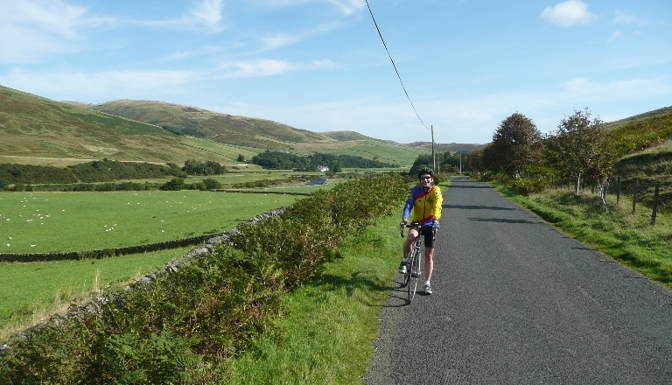
In fact so rubbish, on the way back, having hit a particularly long steep hill I instructed Neil to go get the car. He gleefully headed off, happy to finally put some pace into the day. I plodded on slowly taking frequent rests and enjoying an incredibly steady ride. By the time Neil arrived with the car (he cycled 94 miles) I had cycled 86 miles with over 6.500ft of climbing so not a bad day on tired legs. This was, of course followed by a lovely meal out.
On Friday we rested … that is, we took a short walk in a Scottish National Trust area to view the Grey Mare’s Tail, a spectacular 200ft waterfall and on to Loch Skeen. Note those hills in the background … tomorrow’s run.

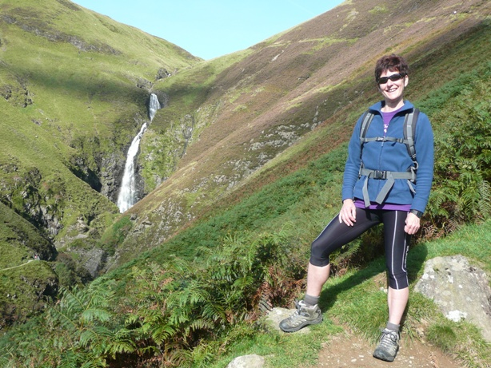
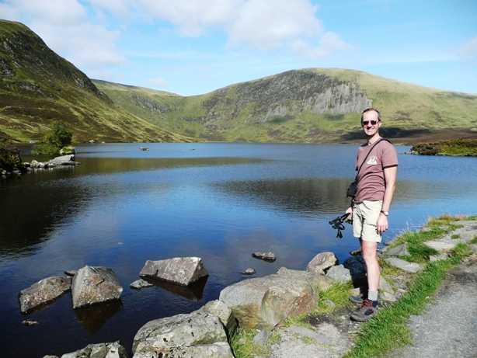

Friends arrived that evening … Becky the Bingley Harrier and hubby Alan, the off-road cyclist. More eating out ☺. (Have I mentioned the full cooked breakfasts and the lunches in cafés yet?)
Becky and I ran the next day, 10 miles and over 3,000ft of climbing – we took our time. We had fantastic views. You may have noticed we were totally blessed with the weather, sunshine every day. On to the Gordon Arms for a late lunch, meeting up with the lads who had spent their morning off-road cycling (only one injury and that was just a flesh wound). A gentle late afternoon walk before yet another really good stuffing at an excellent eating place.
Sunday, our final day and we all headed to Newcastleton for off-road cycling at one of the “stanes”. The 7stanes are seven mountain biking centres spanning the south of Scotland. 'Stane' is the Scots word for stone and at each of the 7stanes locations, there’s a stone sculpture reflecting a local myth or legend. We cycled a Blue-Red route then a Red route. I found it very scary but didn’t fall off and only let out a small squeal of obscenities once. I think could get the hang of it if I ever manage to do this more than once a blue moon.

Running Library

Using the library:Locker 18. Chose your book, write your name and date on the card and leave the card in the locker so we know where the book is.

Book List
in The Runner's Diet (Runners World), Madelyn H. Fernstrom
in Paula My Story so Far, Paula Radcliffe
out Running Made Easy, Susie Whalley
out The Complete Book of Running for Women, Claire Kowalchik
out Absolute Beginner's Guide to Half Marathon Training, Heather Hedrick
out Run Fast: How to Beat your Best Times Everytime, Hal Higdon
in The Runner's Handbook, Bob Glover
out The Competitive Runner's Handbook, Bob Glover & Shelly Lynn Glover
in Marathon: From Start to Finish, Sam Murphy
in Marathon Running for Mortals, John Bingham
in 4 Months to a 4 Hour Marathon, Dave Kuehls
out Marathon Running Beginner to Elite, Richard Nerurka

Running Magazines available to borrow from the table in the club room

Racing and Running Events

Event | Distance | Date | Where
Bridlington Half | Half Marathon | Sunday 18th October | Bridlington
Haltemprice 10K | 10K | Sunday 25th October | Hull
Guy Fawkes 10 | 10 miles | Sunday 1st November | Ripley, Harrogate
Thorpe Park 10K | 10K | Sunday 15th November | Cleethorpes
Boxing day 10K | 10K | Saturday 26th December | Hull
Brass Monkey | Half Marathon | Sunday 24th January | York
Headlands 10K | 10K | Postponed pending permission | Cottingham
** Dates subject to change **

Various distances available so hopefully something for everyone to choose from. It’s always nerve wracking to start with (even if you’ve run lots of races) but very rewarding when you’ve finished!! Race entry forms can be found on the WHL website as well as the entry form folder in the meeting room. More will be added as and when they become available.
NOTE: Club Vests must be worn at any races you enter under the West Hull Ladies running club name

Clubwear

Vest - £15
T- shirt - £16.50 ( 10, 14, 16 only)
Hoodie - £14
Jacket - £24.50

Jackets and hoodies ordered on request.

